News release
4 August 2015
Mick George Ltd fund major improvements at Rushton Lake for Desborough & Rothwell Angling Club
Major improvements have been made to Rushton Lake following a grant of nearly £50,000 from Mick George Ltd.
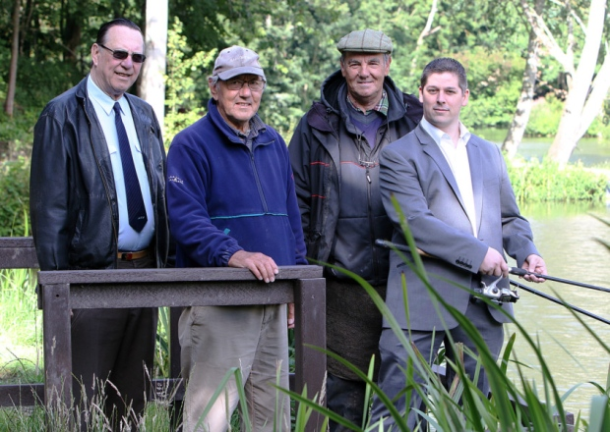

The works included tree cutting, securing banks with piling and new recycled plastic platforms with two specifically for the disabled. New paths around the lake and a significant stocking of carp were also added.

The club tries to provide a safe environment for anglers at the cheapest cost and any surpluses are used for buying fish or minor maintenance. Over the years the lake had deteriorated with the bank collapsing and the fishing platforms becoming a safety hazard.

Without the grant the lake would not be fishable and the club may have had to give up the lease and the 350 existing members, mainly local anglers, would have to fish elsewhere.

Desborough & Rothwell Angling Club is yet another project to benefit from by the Mick George Community Fund.

The Mick George Community Fund which is managed by Grantscape, an independent charity, supports community projects that are located in the vicinity of their operating sites in Northamptonshire, Cambridgeshire, Lincolnshire and Rutland. Up to £200,000 is made available each year for community projects that deliver significant environmental benefits and provide new and better community amenities.

The £50,000 grant has not only secured the club’s future in respect of the improvements but also the landlord, Mr David Pain, has granted a further 10 year lease. The club will be forever grateful to Mick George Ltd, Grantscape for their advice and guidance and David Pain for his help on the project.

Jon Stump, Finance Director at Mick George Ltd said: “We are very pleased to be able to support this unique project through ‘The Mick George Community Fund’ and provide a safer environment at Rushton Lake for local anglers. This money has enabled the Desborough & Rothwell Angling Club to make the much needed improvements around the lake including building brand new fishing platforms and paths so more anglers can access these excellent facilities.”
“All major companies have an impact on the people around them and our aim at Mick George Ltd is to build positive relationships with all local communities. Every year we make over £200,000 available for community and conservation projects within a certain radius of our operating sites. The Mick George Community has supported lots of projects over the years including building two brand new skate parks in Earith and Higham Ferrers, funding the casting of a new bell at Rothwell Church, creating a nature conservation area at Cow Hollow Wood, Waterbeach and many many more.”

The Mick George Community Fund provides grants to the local community. To see if you are eligible and to find out more visit http://grantscape.org.uk/fund/mick-george-community-fund/

ENDS

For further information, please contact:
Stuart Costello, Head of Marketing at Mick George: marketing@mickgeorge.co.uk
Tel. 01480 499 134
About Mick George:
- Mick George has grown to become one of the leading suppliers to the construction industry in East Anglia and the East Midlands with a commercial fleet size in excess of 240 HGV vehicles.
- They specialise in bulk excavation, demolition & earthmoving services, ready mixed concrete, a wide range of skip hire and waste management services, Commercial Trade Waste Service and aggregate supply.
- Mick George has an extensive network of operating sites strategically located across their operating region including quarries, landfill, transfer stations, concrete batching plants, state-of-the-art recycling centres and soil washing facilities.
- They have recently launched a brand new Commercial Waste service for businesses across East Anglia and the East Midlands.
- The rapid growth of Mick George over the years has led to the creation of 100’s of new jobs within the local area, and Mick George Ltd now employs over 550 staff.
- The business growth of Mick George has been recognised with a number of awards, including winning the 2015 Cambridge Business Award for Growth and being ranked in the Sunday Times Fast Track 100 league table in 2015.
- One of the company’s main priorities is support within the local community. Mick George is heavily involved in sponsorship of both small local sports club, such as St Ives F.C and Park Farm Pumas, as well as much larger sports clubs like Peterborough United and Cambridge United. The company prioritises involvement in local events, environment and charities, most recently setting a challenge to raise £50,000 for Sue Ryder Thorpe Hall Hospice which it smashed within 3 months of launch.
- For further information, please visit: http://www.mickgeorge.co.uk

