News Release
7th Sept 2015
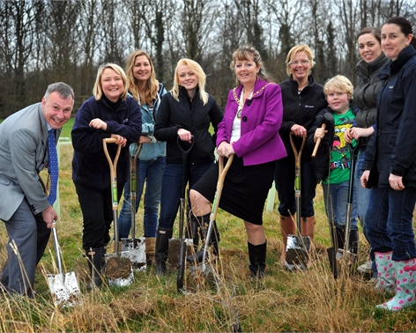

Forest for Peterborough receives funding from Mick George Community Fund

Forest for Peterborough is a charitable project formed by Peterborough Environment City Trust (PECT). The development aims to plant in excess of 180,000 tress within the direct proximity of the city and surrounding towns or villages. The mission is to plant one tree for every person in the city before 2030.

Over 84,000 tress have been planted to date, bringing together communities, schools and businesses for volunteer planting days. The ambitious community project is one that is envisaged to benefit present residents, visitors and legacies for years to come. Once complete, it should be a truly remarkable spectacle to witness.

Thanks to the Mick George Community Fund the project should be able to achieve its long term vision of increased tree coverage, and improved community environments that families can enjoy whilst combatting any adverse climatic conditions that may develop.

Simon Belham, Projects Officer said: “We were absolutely delighted to receive a grant of £32,280 from the Mick George Community Fund for Forest for Peterborough. This generous support will enable us to extend our services to create more wooded areas in Peterborough, making it an increasingly more sustainable city for years to come.”

The Community Fund which is managed by Grantscape, an independent charity, supports community projects that are located in the vicinity of Mick George Ltd operating sites in Northamptonshire, Cambridgeshire, Lincolnshire and Rutland. Up to £200,000 is made available each year for projects that deliver significant environmental benefits and provide new and better community amenities.

Jon Stump, Finance Director at Mick George Ltd ‘’The scheme has proven invaluable to many local communities, helping to create, restore and protect a whole array of landmarks and projects. Since 2010 when the programme was launched, £682,000 has been invested in over twenty five individual developments.’’

The Mick George Community Fund provides grants to the local community. To see if you are eligible and to find out more visit http://grantscape.org.uk/fund/mick-george-community-fund/

ENDS

For further information, please contact:
Stuart Costello, Mick George: marketing@mickgeorge.co.uk
Tel. 01480 499 134

About Mick George:
- Mick George has grown to become one of the leading suppliers to the construction industry in East Anglia and the East Midlands with a commercial fleet size in excess of 240 HGV vehicles.
- They specialise in bulk excavation, demolition & earthmoving services, ready mixed concrete, a wide range of skip hire and waste management services, Commercial Trade Waste Service and aggregate supply.
- Mick George has an extensive network of operating sites strategically located across their operating region including quarries, landfill, transfer stations, concrete batching plants, state-of-the-art recycling centres and soil washing facilities.
- They have recently launched a brand new Commercial Waste service for businesses across East Anglia and the East Midlands.
- The rapid growth of Mick George over the years has led to the creation of 100’s of new jobs within the local area, and Mick George Ltd now employs over 550 staff.
- The business growth of Mick George has been recognised with a number of awards, including winning the 2015 Cambridge Business Award for Growth and being ranked in the Sunday Times Fast Track 100 league table in 2015.
- One of the company’s main priorities is support within the local community. Mick George is heavily involved in sponsorship of both small local sports club, such as St Ives F.C and Park Farm Pumas, as well as much larger sports clubs like Peterborough United and Cambridge United. The company prioritises involvement in local events, environment and charities, most recently setting a challenge to raise £50,000 for Sue Ryder Thorpe Hall Hospice which it smashed within 3 months of launch.
- For further information, please visit: http://www.mickgeorge.co.uk

