News Release
14th Sept 2015
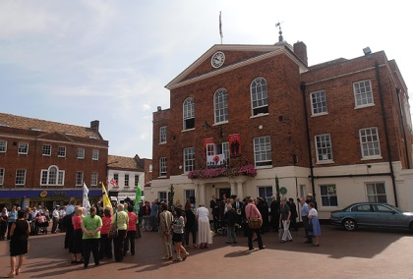

Energy Efficiency Improvements at Huntingdon Commemoration Hall courtesy of the Mick George Community Fund

Built in 1840, Huntingdon Commemoration Hall a town centre venue available to individuals and groups within the local community for recreational and leisure activities has recently undergone significant maintenance thanks to a £37,000 grant from Mick George Ltd.

The funding has facilitated new ‘zoned’ heating systems which will provide both social and environmental benefits. Conditions for guests have dramatically improved providing a far more pleasurable experience, and the benefits do not stop their. Energy efficiency levels have developed and are forecast to provide financial savings estimated to be around 50% for further investment.
Marilyn Bailey, Commemoration Hall Manager commented: “The existing boiler system has been rapidly deteriorating for some time, and it was unlikely that it would see us throughout the Winter. Without the funding we would not have been able to replace the boiler system which would inevitably mean the closure of the hall, impacting immensely on all users of the facility.
Bailey continued: ‘’The ‘Hall’ is here to benefit the entire community. On behalf of all connected to the premises, I would personally like to say a huge thank-you to Mick George Ltd who have made this project possible.”
The Community Fund which is managed by Grantscape, an independent charity, supports community projects that are located in the vicinity of Mick George Ltd operating sites in Northamptonshire, Cambridgeshire, Lincolnshire and Rutland. Up to £200,000 is made available each year for projects that deliver significant environmental benefits and provide new and better community amenities.
Jon Stump, Finance Director at Mick George Ltd ‘’The scheme has proven invaluable to many local communities, helping to create, restore and protect a whole array of landmarks and projects. Since 2010 when the programme was launched, £682,000 has been invested in over twenty five individual developments.’’
The Mick George Community Fund provides grants to the local community. To see if you are eligible and to find out more, please visit http://grantscape.org.uk/fund/mick-george-community-fund/

ENDS

For further information, please contact:
Stuart Costello, Mick George: marketing@mickgeorge.co.uk
Tel. 01480 499 134

About Mick George:
- Mick George has grown to become one of the leading suppliers to the construction industry in East Anglia and the East Midlands with a commercial fleet size in excess of 240 HGV vehicles.
- They specialise in bulk excavation, demolition & earthmoving services, ready mixed concrete, a wide range of skip hire and waste management services, Commercial Trade Waste Service and aggregate supply.
- Mick George has an extensive network of operating sites strategically located across their operating region including quarries, landfill, transfer stations, concrete batching plants, state-of-the-art recycling centres and soil washing facilities.
- They have recently launched a brand new Commercial Waste service for businesses across East Anglia and the East Midlands.
- The rapid growth of Mick George over the years has led to the creation of 100’s of new jobs within the local area, and Mick George Ltd now employs over 550 staff.
- The business growth of Mick George has been recognised with a number of awards, including winning the 2015 Cambridge Business Award for Growth and being ranked in the Sunday Times Fast Track 100 league table in 2015.
- One of the company’s main priorities is support within the local community. Mick George is heavily involved in sponsorship of both small local sports club, such as St Ives F.C and Park Farm Pumas, as well as much larger sports clubs like Peterborough United and Cambridge United. The company prioritises involvement in local events, environment and charities, most recently setting a challenge to raise £50,000 for Sue Ryder Thorpe Hall Hospice which it smashed within 3 months of launch.
- For further information, please visit: http://www.mickgeorge.co.uk

