Ecological Constraints Mapping Using BIM
In July 2016, the A1 Leeming to Barton Scheme presented our ornithological mapping as part of a Considerate Constructors Scheme monitor’s visit. Our work in this area was approved as an innovation. Since this visit, we have ‘further developed and improved’ this innovation through the use of Building Information Modelling (BIM) technology.
We have gone beyond nesting bird mapping to aid British Trust for Ornithology data collection to ensure that we, we have captured all protected species present on the scheme, as well as other ecological constraints. When the BIM model for our scheme is running, the various ecological constraints i.e. active bat roost, pop up as a specific warning symbol informing of key ecology issues. Our team are then advised to seek advice from the Project Environmental Advisor.
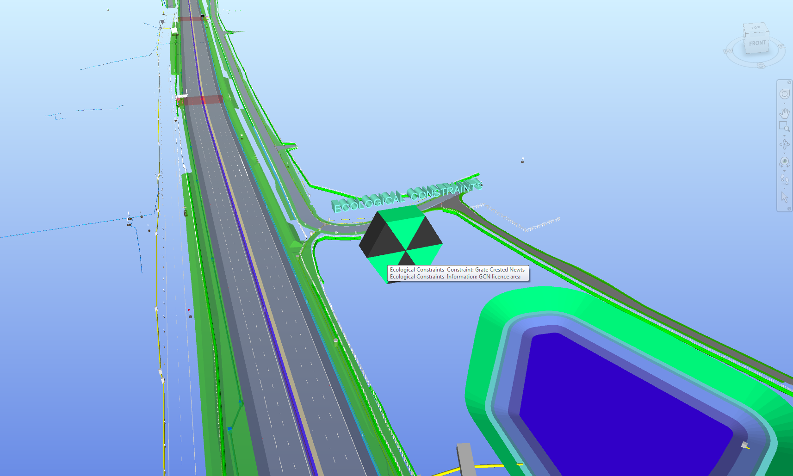
Whilst BIM has previously been used to map health and safety hazards, we believe that the use of the technology to map protected species and raise awareness of ecological constraints is an innovative activity and is certainly the first example of its use within our business. By incorporating ecological information into the model, we have been able to enhance the existing advantages of using BIM:
- Visualisation – rather than seeing a dot on a plan, the BIM model allows the user to visualise the exact location of the ecological constraint within the context of the built scheme
- Clash prevention – placing the ecological constraints within the model allows the user to see where ecological issues could clash with sequencing of works in specific areas on the scheme
- Collaboration – increases the level of coordination and communication between all project disciplines
- Knowledge and awareness – the model is accessed from every level within the project and externally at public forums; therefore the environmental constraints on the scheme receive greater exposure and focus.
Our project has produced a case study on the use of BIM for ecological constraint mapping which has been circulated within our parent companies and can be used in future work winning efforts to demonstrate the use of technology for environmental benefits.
NOTE – sensitive ecological information such as active badger setts would be removed from the model in certain circumstances and a non-specific ecological constraint would be highlighted in its place.

