Nottingham City Centre -things to do:

Food & Drink
- Stonebridge City Farm - Address: Stonebridge Road | St Ann's, Nottingham NG3 2FR, England.
- Debbie Bryan Pub - Address: 18 St. Mary's Gate | The Lace Market, The Creative Quarter, Nottingham NG1 1PF, England.
- Raglan Road Irish Bar - Address: 69-73 Derby Road, Nottingham NG1 5BA, England.
- Castle Rock Brewery - Address: Queens Bridge Road, Nottingham NG2 1NB, England.
Outdoor Activities
- Nottinghamshire Golf & Country Club - Address: Cotgrave, Nottingham NG12 3HB, England.
- National Water sports Centre - Address: National Water Sports Centre Adbolton Lane | Holme Pierrepont Country Park, Nottingham NG12 2LU, England.
- Nottingham Off-Road Events - Address: Lockwell Hill Activity Centre | Farnsfield, Newark, Nottingham NG22 8BP, England.
- Nottingham Forest FC, the City Ground - Address: Pavilion Road, Nottingham NG2 5FJ, England.

Fun & Games
- Escapologic - 21-23 Castle Gate, Nottingham NG1 7AQ, England.
- Dusk till Dawn Casino - Address: Redfield Way | Boulevard Retail Park, Nottingham NG7 2UW, England.
- The Glee Club - Address: Waterways Building Castle Wharf Canal Street | The Waterfront, Nottingham NG1 7EH, England.
- Showcase Cinema - Address: Redfield Way, Nottingham NG7 2UW, England.

Nightlife
- The Factor Lounge - Address: 22 Union Road, Nottingham NG3 1FH, England.
- Tilt, Cocktail Bar - Address: 9 Pelham Street, Nottingham NG1 2EH, England.
- Manvers Arms - Address: The Cross, Nottingham NG12 3HS, England.
- Coco Tang - Address: 45 Bridlesmith Gate, Nottingham NG1 2GN, England.

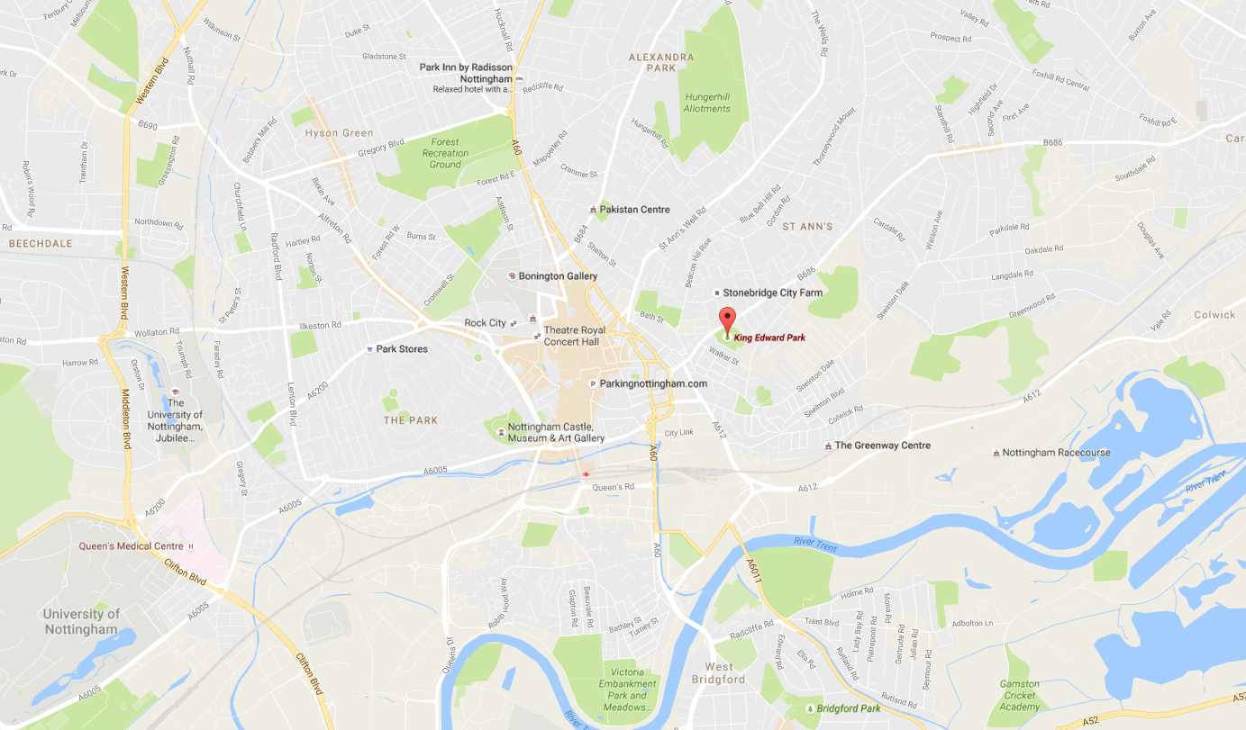
Location of Site

