Elide Fireball extinguisher 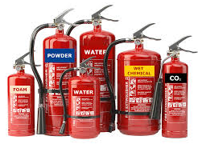 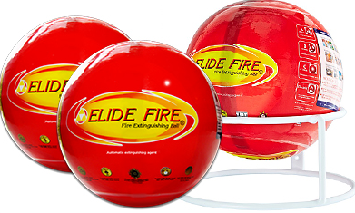
Issues | Conventional Fire Extinguishers | Elide Fire Ball extinguishing
Training & Skill Requirement | Firefighting trained and competent | No requirement for training or assessment as this also operates in auto mode.  Used by throwing towards the fire
Selection of Extinguisher category | Extinguishers are selected as per Class of fire – A, B or C type fires | Fireball Caters for all three categories of fire A,B and C
Weight of Extinguishers | Difficult to carry and heavy:  Domestic weights range between 2.0 – 7.3kg  Industrial ones range between 5.0 – 9.0Kg | Easy to carry and use:  Weighs around 1.3kg (+/-) 5% for use in domestic and industry purposes
Human Safety | To operate the user has to go be in close proximity of the fire inviting the associated hazards and risk | The fireball can be rolled or thrown from a distance away from the fire  The auto mode also puts out the fire with the need of human interaction
Maintenance | Exchanged for a tested one or a new one every 6months  Inspected daily for any discharge | No Inspection/maintenance required for 5 Years
Cost analysis and savings | Average cost £30.00  6 month before maintence/replacement  Cost over 5 years (average) £600 | Price to buy for 1 £95.00  Has a 5 years lifespan  Cost over 5 years £95.00  No maintenance costs  Savings of around £500
Operation timing | 100% Manual  Average time till opening the nozzle is around 1 – 5 minutes | Self-Activated  When this comes into contact with a fire flame the fireball activates within 3-10 seconds
Distance coverage/ Usage | 2 Meters in straight line mean the operative will need to be a minimum 2 meters away from the fire | Will cover 9.12 m2 and can be thrown from a distance away so minimum requirement
Environmental Concerns | Most are made from CFC & other materials which are of toxic nature | Is free from CFC as made from mono ammonium phosphate dry powder – which are Non-toxic and Eco Friendly
Space Required | Min: 2ft x 6inch | 6inch by 6inch

