STORAGE OF FUEL

All plant must be driven up to the refuelling zone for refuelling.

Where fuel is not within a bunded tank, it must be stored on a
fuel sump within our material stores.

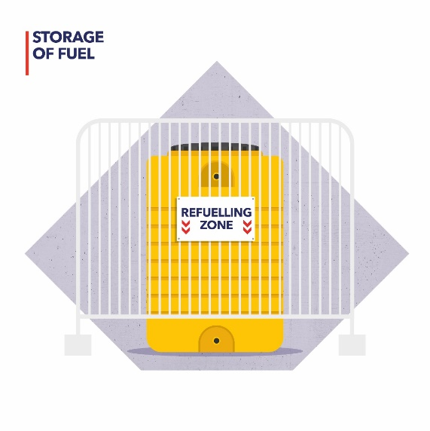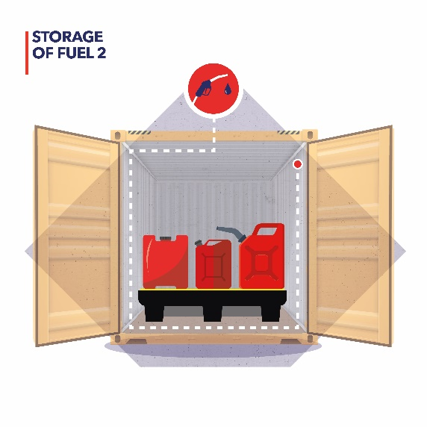

REFUELLING OF PLANT AND EQUIPMENT

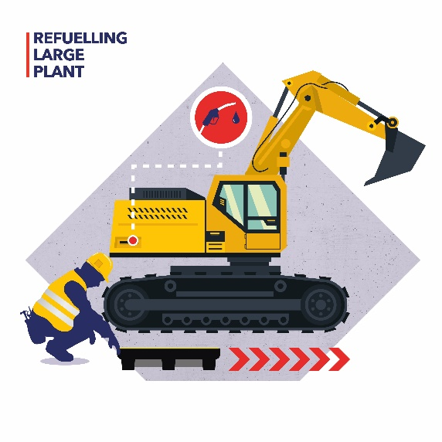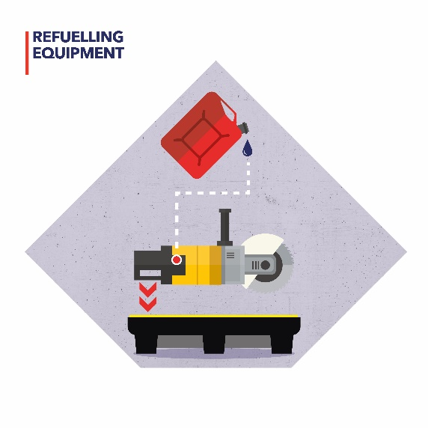
All plant must be refuelled over a drip tray.

All refuelling of other equipment must also take place on a drip tray

Introduction

This procedure identifies the controls to be followed when re-fuelling construction plant on site.

Fuel Storage

All fuel stored on construction sites must be kept in appropriate containers.

Small Containers

Small amounts of fuel may be stored in portable containers that are specifically designed for the storage of fuel and are clearly marked with their contents.

Fuel containers that are stored partially full must be stood on a suitable bund.

Fuel containers must be stored away from sources of ignition.

Bulk Containers

Bulk fuel must be contained in bunded tanks specifically designed for the storage of fuel.

Containers must indicate the volume and type of fuel stored.

If any taps or pipes used for re-fuelling are not stored within the tank, secondary bunds must be provided to collect and drips.

Storage limits

For petrol

You cannot store more than 30 litres in cans
You cannot store more than 275 litres in a tank (which must be bunded)

If you store more than these amounts you would need licence/permits

For diesel

Any tank with a volume above 200 litres must be bunded

Fuel Deliveries

Fuel deliveries to the tanks should be carried out under supervision.

The delivery driver should ensure that there is protection in place to collect any drips.

Any spillages must be addressed before the delivery driver leaves the site.

Re-fuelling

Re-fuelling must only take place in designated areas.

Wherever possible re-fuelling areas shall be on hard-standing and located away from surface drains or water courses.

Spill kits and fire extinguishers should be available close to the re-fuelling area.

Plant to be re-fuelled should be located as close to the fuel tank as is practicable, to avoid long hose runs.

Drip trays must be placed under any hose during the re-fuelling process.

After re-fuelling the operator must make sure that all equipment is returned to the designated location, all taps are fully closed and any spillages are addressed.

Spillages

Any spillages must be addressed as soon as possible in accordance with the Spillage Procedure (DOC16).

