CONCRETE WASHOUT

All concrete mixer trucks & bricklayers must follow the correct procedure for cleaning their funnel / chute before leaving site.

This washout zone must be located away from any trees, vegetation and watercourses on site.

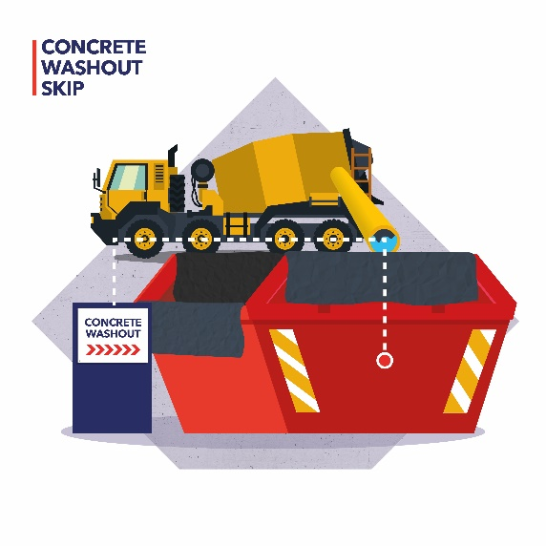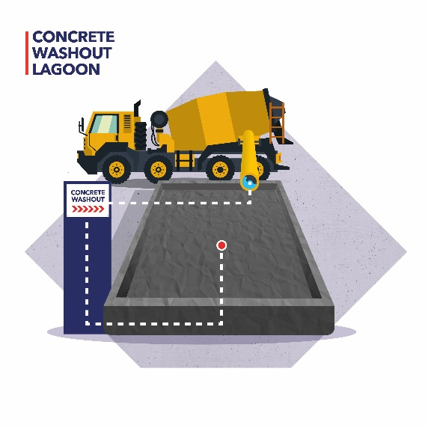

MORTAR DISPOSAL

Dry mortar is inert and non-hazardous to the environment, therefore it can be tipped into a controlled area, directly onto the ground. Wet mortar must be left to set.

Waste bricks & blocks can go into the same location.

This washout zone must be located away from any trees, vegetation and watercourses on site.

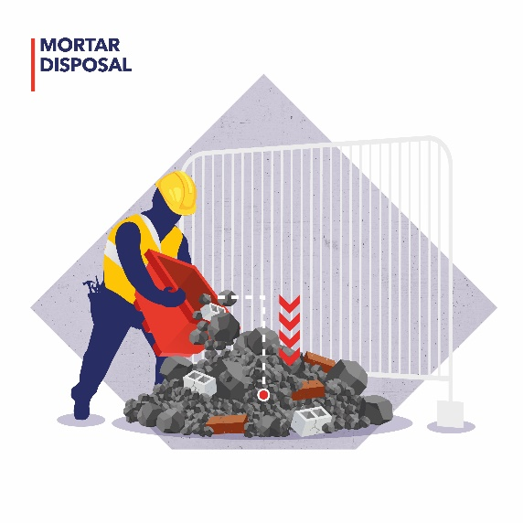
Introduction

All concrete mixer trucks & bricklayers must follow the correct procedure for cleaning their funnel / chute before leaving site to comply with the Environment Agency’s Regulatory Position Statement (RPS_107).

The following options should be read in conjunction with the RPS_107.

- Discharge to foul sewer
  - This can be done with written consent from the sewerage provider where reuse is not possible

- Discharge to ground
  - Untreated small (<10 deliveries / week) wash water discharges or partially-treated medium (<50 deliveries / week) wash water discharges can be made to ground. Refer to RPS_107 for further information

- Discharge to surface water
  - Can only be done with fully treated waste water and must abide by several rules (again refer to RPS_107 for information)

NOTE: SHOULD YOU WISH TO UNDERTAKE ANY OF THE ABOVE METHODS, THE ENVIRONMENT AGENCY REQUIRE YOU TO COMPILE AN APPROPRIATE ASSESSNENT OF THE SURROUNDING AREA AND RECEPTORS. SEE APPENDIX 2 IN RPS_107 FOR GUIDANCE ON THE FORMAT OF YOUR ASSESSMENT.

If you cannot dispose of waste water via the above methods, there are a number of options available for site teams.

Typically, all concrete mixers should be washed out by the following procedures. These are (in order of preference):

- Wash out skip ^{N1}
- Use a mortar tub / bucket for wash out ^{N2}
- Create a ‘soakaway’ – a plastic lined reduced level dig ^{N3}
- Create an ‘evaporation lagoon’ – a plastic lined reduced level dig ^{N4}
- Concrete supplier take-back ^{N5}

NOTE: ONLY CONCRETE AND MORTAR THAT IS FULLY DRY CAN BE TIPPED DIRECTLY ONTO THE GROUND INTO A CONTROLLED AREA

Wash out skip ^{N1}

The wash out skip must be fully lined in an impermeable plastic sheet. The water levels must be kept at a reasonable level. Excess water can be left to evaporate, be extracted via water pump or pumped into a tanker and removed from site for treatment and disposal.
Mortar tub ^{N2}

Excellent for sites with limited space, a mortar tub can be filled with concrete slurry and washout water. Water can be left to evaporate or pumped out using a water pump for treatment and disposal.

Soakaway ^{N3}

A permeable geo-textile (such as Terram) within a reduced level dig must be in place to separate washout water from concrete residue. The leftover waste could be broken up and disposed of correctly with other inert wastes.

Ensure the Soakaway is placed in a location which meets the Washout Area Location guidance below.

Evaporation Lagoon ^{N4}

An Evaporation Lagoon comprises of a reduced level dig with an impermeable membrane / plastic sheet in place. You must ensure the plastic sheet is kept in good condition as any concrete which goes past the lining could contaminate vegetation or local watercourses. Ensure the Evaporation Lagoon is placed in a location which meets the Washout Area Location guidance below.

Concrete supplier take-back ^{N5}

The concrete supplier must ensure that a Concrete Sock or similar product is in place to ensure waste concrete, gravel etc does not go onto the highways.

Washout area location

You must ensure the wash out zone is easily accessible for the duration of the contract.

The washout area should be situated as far away as practically possible, and within site constraints, from storm drain inlets, open drainage facilities, watercourses and trees (roots absorb water) but close enough to site to prevent spills, drips etc onto open ground. (Refer to RPS_107 for more information).

NOTE: IF ANY CONCRETE OR OTHER SUBSTANCE CANNOT BE CONTAINED THE ENVIRONMENT AGENCY MUST BE CONTACTED ON THE 24HR EMERGENCY LINE 0800 807060

- Report

- For concrete spillages of more than 10 litres a complete a non-conformance report Q02

- For any concrete spillage that enters the drainage system complete a non-conformance report Q02

