Dear [name]
Compliance with the CLOCS Standard
[Company name] is committed to improving health and safety standards across its operations, including reducing work-related road danger.
In response to the number of fatal and serious collisions involving construction traffic and vulnerable road users, the construction industry is working together to improve road safety. You may already be aware of the ‘CLOCS Standard which is supported by the Health and Safety Executive and Department for Transport.
We believe that no death or injury on the road is acceptable which is why we are implementing the CLOCS Standard on our construction sites and mandating the CLOCS Standard across our supply chain. The CLOCS Standard contains requirements for all key stakeholders associated with a construction project and, in the context of this letter, is applicable to all suppliers using vehicles over 3.5 tonnes gross vehicle weight.
Optional text if your company operates its own vehicles:
Our own fleet of heavy goods vehicles meets the requirements described as Silver in the FORS Standard, and in order to fully realise the objectives of the CLOCS Standard, it is imperative that these requirements are implemented across our entire supply chain.
To this end [Company] will mandate compliance with the CLOCS Standard. From [Insert date] all suppliers must present acceptable evidence that they meet the Standard described as Silver in the FORS Standard.
After this date, we reserve the right to carry out checks on vehicles and drivers arriving at our sites. Non-compliant vehicles and drivers may be turned away from our projects, registered as a failed delivery and/or other appropriate action taken through our commercial departments.
Optional text depending on T+Cs and structured supply chain review: For new projects or additions to our supply chain, you have 90 days from the start of your contract by which to comply.
If a structured supply chain review demonstrates that your suppliers are not yet able to meet the requirements of the CLOCS Standard, then you shall give notice that compliance will be required within six months of advising them to do so, and clearly communicate what needs to be achieved if they wish to continue to win your work.
The requirements of the CLOCS Standard are already mandated by a number of public and private clients and our peers are already enforcing compliance with this common national standard. For a full list of CLOCS Champions visit the ‘Directory’ on CLOCS website.
Visit the FORS website for information about the requirements described as Silver in the FORS Standard
Should you require any further support and assistance, please contact [insert name and contact details within Company].
We are committed to ensuring the vehicles within our supply chain do not pose a risk to other road users. Your assistance is required to achieve this aim and we welcome your support to ensure compliance by the above date to help us all to provide a safer environment for vulnerable road users.
Yours sincerely
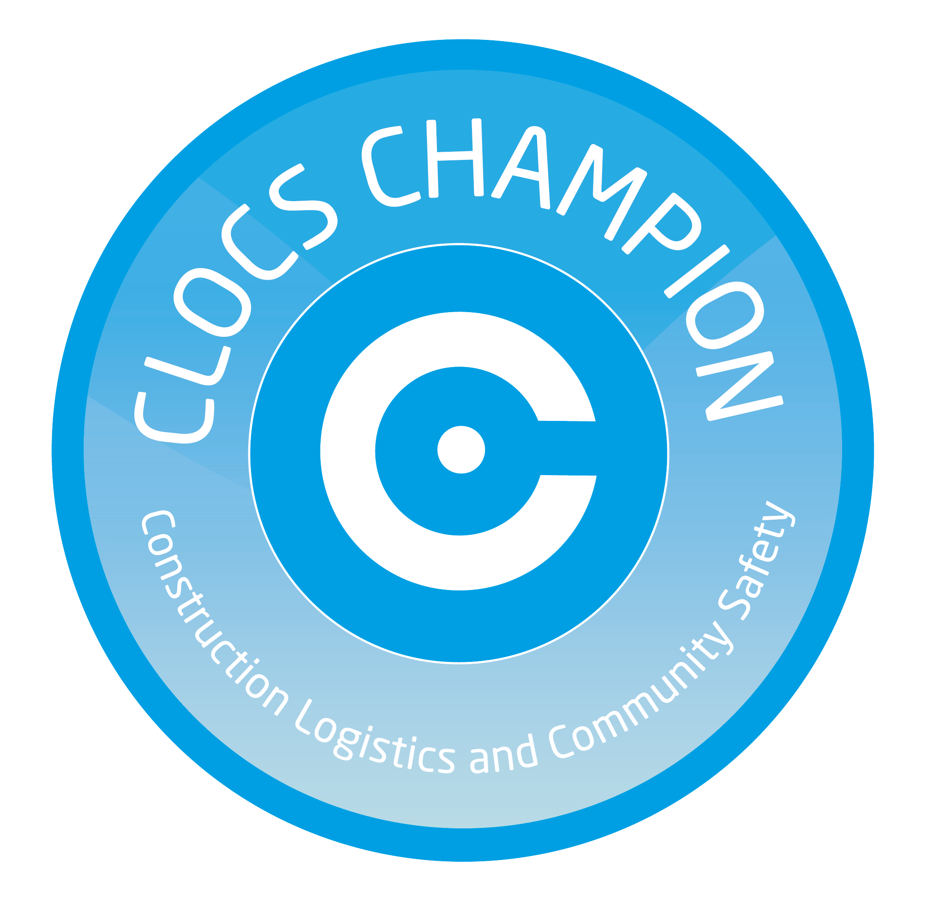
[Insert signatory of authorised person]

includes mobile cranes, concrete pumps & volumetric mixers [Delete this before use] For reference only, this document was last updated in March 2020.

